

FoodRescue AI: Supermarket Food Waste Reduction

Team ID and Team Name: LAB-P6-Team 8

Team Members:
Jariel Seah, 2601663, 2601663@sit.singaporetech.edu.sg
Darren Lee Khai Xuan, 2603021, 2603021@sit.singaporetech.edu.sg
Ng Jiexin, Jacinth, 2604333, 2604333@sit.singaporetech.edu.sg
Quek Wei Foong, 2601766, 2601766@sit.singaporetech.edu.sg
Neo Jun Hui, 2605731, 2605731@sit.singaporetech.edu.sg
Date of submission: 14th October 2026

Table of Contents

Introduction 3
Data Flow Diagram 4
Data Structure and Storage Design 5
Exception Handling Matrix 5

Introduction
Supermarkets frequently face challenges in managing food products that are nearing their use-by dates or experiencing low customer demand. Without immediate action from supermarket staff, these products quickly turn into food waste, resulting in financial losses and environmental harm. According to the United Nations Environment Programme, food loss and waste generate an estimated 8% to 10% of global greenhouse gas emissions.
To address this problem, our team developed FoodRescue AI. This application helps supermarket staff find ways to use food before it goes to waste by suggesting recipes. Through the application, supermarket staff can manage the inventory by viewing, searching and updating records. They are also able to request AI assessments by selecting a product and entering observations about a product’s condition. The AI assessments use details such as the product’s use-by date, quantity, demand, storage condition and allergen information to assess and provide recipe suggestions. Each recipe includes an ingredient list and preparation instructions.
For example, the AI could suggest using tomatoes that are close to their use-by date in a pasta dish. The suggested dish would then be checked against our list of predefined recipes, with any suggestions that do not match being rejected. Additionally, products that are expired, spoiled, or deemed unsuitable for consumption are rejected, regardless of whether the ingredients match the predefined list. Accepted recipes and reasons for rejection are saved for future reference. However, the staff are still responsible for checking food safety before preparing and selling any suggested dishes with the ingredients.
Through FoodRescue AI, we aim to reduce avoidable food waste, improve inventory management efficiency, and help supermarkets maximise the use of available ingredients while maintaining food safety standards.

Data Flow Diagram
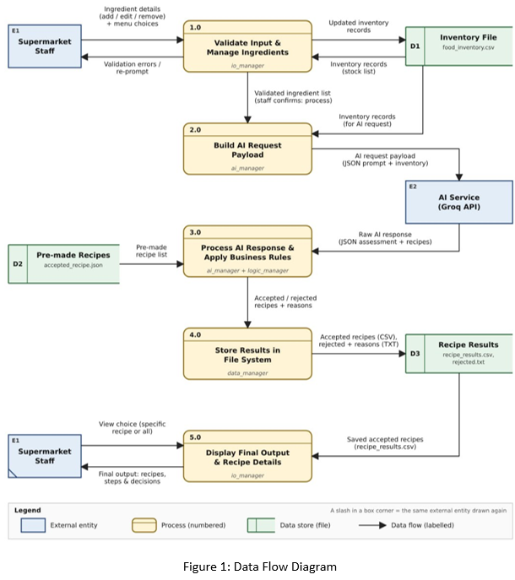

Data Structure and Storage Design
FoodRescue AI stores its data in three different file types. A CSV file holds the supermarket’s food inventory, with fields such as category, use-by date, storage condition, demand level and quantity. JSON files hold the recipe data. recipes.json contains the AI-generated recipes and accepted_recipe.json contains the supermarket’s fixed list of pre-made recipes. Each AI recipe is checked against that list, and approved recipes will be saved to a CSV file (recipe_results.csv). Whereas rejected recipes will be saved to a TXT file (rejected.txt) together with reason for rejection.
Files used | Purpose
food_inventory.csv | Tracks food items by category, use-by dates, days to expiry, storage condition, waste risk, allergens, and demand levels for AI manager to check through
recipes.json | Contains AI-recommended recipes based on selected ingredient, saved with food name, required ingredients and the preparation instructions
accepted_recipe.json | Holds a pre-made recipe list used by logic manager to evaluate the AI-generated recipes and decide whether to approve or reject it based on criteria such as ingredients and recipe name.
recipe_results.csv | Stores approved recipes for supermarket staff, the I/O manager will print for staff to view. Recipes stored will include their name, ingredients contained and instructions on how to make
rejected.txt | Stores rejected recipes along with the reason for rejection by logic manager. The 2 main reasons are ingredients not found in recipe list or recipe name

Exception Handling Matrix
Scenarios | Possible Cause | Detection Method | Handling Strategy | User Outcome
Malformed AI output | Bad User inputs or AI Error | Try and catch blocks | Functions raise value errors and try, except blocks | User is informed of the error and prompted to try again until output Is fixed
API network failure | Network connection unavailable | Request timeout | Terminates safely and notifies the user | User is notified of the unavailable network
Missing API key | apikey.env missing or in the wrong folder, or groq API key empty | ai_manager checks environment variable after load_dotenv | Returns a clear error before making API call | User is informed of the error and told to add API key in apikey.env
Missing AI dependencies | groq or python-dotenv not installed in environment | ImportError caught during import | Notify users that AI dependencies are missing | User is told to install the required dependencies in requirements.txt and retry
Invalid user input or assessment  data | Empty required fields, invalid menu choices, incorrect number or date formats, and poor quality for AI assessment | Input checks in io_manager and assessment validation in ai_manager | Prompts users to correct interactive input and reject invalid assessment data before calling API | User sees the error and can correct the input or inventory record
Missing or empty data files | food_inventory.csv, recipes.json or accepted_recipe.json is missing or empty | load_json_files() returns an error, logic_manager checks for empty recipes.json | Notify users that JSON/CSV file is empty and continues | User is instructed to run the AI step first or restore the file
Recipe rejected by business rules | Recipe name is not on the approved list, or fewer than 60% of ingredients match | logic_manager rule checks | Saves the recipe to rejected.txt with a rejection reason | User sees the accepted count and rejection reasons. Rejected recipes are never displayed as available
Failed save of recipe changes | Read only file, permission error, or disk full | OSError handled in io_manager | io_manager catches the error and reports it | User sees “Failed to add/update/remove” message, the file remains unchanged
API rate limit reached | Too many requests or provider usage limits exceeded | access_with_client() checks HTTP status 429 | SDK retries eligible failures once, and any remaining 429 produces a specific error message | User is instructed to wait or check Groq limits
AI request too large | Request payload exceeds the provider’s limit | access_with_client() checks HTTP status 413 | Returns an error without producing an assessment | User is told to reduce the inventory payload and retry
Failure to save AI-generated recipes | Folder permissions, disk full or another write failure | suggest_recipe() catches OSError, ValueError and TypeError | Uses a temporary file and atomic replacement, and returns SAVE_ERROR on failure | User sees “Could not save recipe.json. Check folder permissions and retry.”

